INDUSTRIAL TRAINING
REPORT/SUMMER TRAINING
REPORT

Submitted in partial fulfillment of the
Requirements for the award of
Degree of Bachelor of Technology in CSE

Name : SARVJEET SINGH
UNIVERSITY ROLL NO : 00717707223
SEMESTER : 5th
Academic Year : 2024-25

DECLARATION

I hereby declare that the Industrial/ Summer Training Report entitled (Cryptography and Network Security) is an authentic record of my own work as requirements of Industrial Training during the period from _______to_______ for the award of degree of B.Tech. (AIDS/AIML/CSE) School of Engineering and Technology, VIPS-TC.


(SARVJEET SINGH)
(00717707223)

Date: ____________________

CERTIFICATE
This is to certify that Mr. / Ms.___________________________ has partially completed / completed Industrial Training during the period from _______to in our_______Organization / Industry as a Partial Fulfillment of Degree of Bachelor of Technology in
AIDS/AIML/CSE. He / She was trained in the field of ______________________________ .

Signature & Seal of Training Manager
Note: This certificate must be typed on the company letter head/ or provided by the company.
Add photocopy of provided certificate

Contents:

Candidates Declaration………………………………………………………………….
Certificate……………………………………………………………………………….
Acknowledgement……………………………………………………………………….
Company Overview………………………………………………………………………
Abstract…………………………………………………………………………………
List of Tables…………………………………………………………………………….
List of Figures……………………………………………………………………………
Abbreviations and Nomenclature………………………………………………………

Chapter 01: Introduction
1.1 Introduction to Cryptography and network security
1.2 Classification of cryptography and network security
1.3 Scope of Cryptography and network security ………………………………………………..
Chapter 02: Tools and Technology Used……………………………………………………………
Chapter 03: Snapshots of Project …………………………………………………………………………………
Chapter 04: Summary of the project
Chapter 05: Conclusion and Future Scope……………………………………………………….
5.1 Conclusion………………………………………………………………………………………
5.2 Future Scope…………………………………………………………………………………..
References…………………………………………………………………………………………….
Appendices…………………………………………………………………………………………..

ACKNOWLEDGEMENT

I take this opportunity with much pleasure to express my sincere gratitude to my college for granting me to do this Six Weeks Industrial Training at Scientific Analysis Group (SAG), DRDO, Ministry of Defence, Metcalfe House, Delhi – 110054.

I am extremely grateful to Mr. Ashish Sonkar Scientist ‘E’ for his guidance and patience in helping me complete the project and make the most of the training here at SAG. He took the time to explain many security concepts from scratch which were relevant to the project and also extended the explanations beyond the project. The learning was truly beneficial and fostered a greater interest in cybersecurity.

I am also thankful to my Faculty Mentor, Dr. Gopal Chaudhary (VIPS-TC) for supporting me and encouraging me in pursuing and completing this training.

I would also like to thank Dr. Nihar Ranjan Roy, Head of Computer Science Engineering Department, VIPS-TC for granting me the permission to pursue this training.

Last but not the least I wish express my gratitude to my beloved parents for their support, strength and help for everything.

SARVJEET SINGH

Place: New Delhi
Date:

ORGANISATION INTRODUCTION

DEFENCE RESEARCH & DEVELOPMENT ORGANISATION
DRDO works under Ministry of Defence. DRDO dedicatedly worked towards enhancing self-reliance in Defence Systems and undertakes design & development leading to production of world class weapon systems and equipment in accordance with the expressed needs and the qualitative requirements laid down by the three services.
DRDO is working in various areas of military technology which include aeronautics, armaments, combat vehicles, electronics, instrumentation engineering systems, missiles, materials, naval systems, advanced computing, simulation and life sciences. DRDO while striving to meet the Cutting edge weapons technology requirements provides ample spinoff benefits to the society at large thereby contributing to nation building.
Vision
Make India prosperous by establishing a world-class science and technology base and provide our Defence Services decisive edge by equipping them with internationally competitive Systems and Solutions .
Mission
Design, develop and lead to production state-of-the-art sensors, weapon systems, platforms and allied equipment for our Defence Services.
Provide technological solutions to the Defence Services to optimise combat effectiveness and to promote well-being of the troops.
Develop infrastructure and committed quality manpower and build a strong technology base.

Core Competence
Dept of Defence Research and Development (R&D) is working for indigenous development of weapons, sensors & platforms required by the three wings of the Armed Forces. To fulfill this mandate, Dept of Defence Research and Development (R&D), is closely working with academic institutions, Research and Development (R&D) Centres and production agencies of Science and Technology (S&T) Ministries/Depts in Public & Civil Sector including Defence Public Sector Undertakings & Ordnance Factories.

Training and Development
DRDO has a dynamic training and development policy which is executed through the Continuing Educational Programmes (CEP) for all cadre personnel viz DRDS, DRTC, Admin & Allied. At the entry level in DRDS, the newly recruited scientists undergo a 16 weeks Induction Course at Institute of Armament Technology (IAT), Pune. Under the Research and Training (R&T) scheme the scientists are sponsored for ME/M Tech programmes at IITs/IISc and reputed universities. The fees are also reimbursed by the DRDO where scientists undergo Ph.D programmes. In addition to this, the Organisation through its two premier Institutes namely Institute of Technology Management (ITM) and Institute of Armament Technology (IAT) deemed universities offer courses for scientists and Armed Forces in the area of Technology Management, R&D Management and Armament. Recently, a training centre at Jodhpur has been established to meet the training needs for Admin & Allied cadre. In order to attract the futuristic talent, DRDO has Junior Research Fellow (JRF), Senior Research Fellow (SRF) and Research Associate (RA) schemes for young & dynamic personnel & interested in Defence Research and Development.
About Scientific Analysis Group (SAG)
Historical Background

Scientific Analysis Group (SAG) was established in 1963 for evolving new scientific methods for design and analysis of communication systems. It was situated in the Central Secretariat Complex and consisted of 12 scientists. This group was placed under direct control of the Chief Controller (R&D) in 1973 and became a full-fledged Directorate in R&D Headquarters.
In 1976, SAG started undertaking R&D projects on mathematical, communication and speech analysis. Due to the increasing responsibilities of SAG, the manpower component of SAG underwent expansion and additional accommodation was allotted to SAG at Metcalfe House Complex.
SAG was further entrusted with R&D work in the field of electronics. Work related to evaluating communication equipment to be introduced in Services was taken up during 1980. The manpower structure was again revised and the electronic facilities were enhanced.
Presently SAG is housed in two independent buildings with a total manpower of 140 scientists/technical and other staff.
Areas of Work
- Advanced Mathematical and Statistical Analysis & Development of Tools
- Linguistics - Computational and Structural
- Speech Analysis - Recognition and Synthesis
- Simulation Studies
- Microprocessor-based Systems
- Signal Processing
- Satellite Communication
- High performance computing
Products
SAG is the lab working on the projects and other R&D activities directly related to use by Services. Some of the electronic systems are in use by other Govt Agencies.
Facilities Available
- Simulation Laboratory.
- Speech Laboratory.
- Hardware Laboratory.
- System Analysis Support Laboratory.
- 16 Node Distributed Computational Facility.
- Excellent Tech Library with around 10000 books and National/International Journals.
- 256 Dual Processor Nodes Distributed Computing Infrastructure.

1.1 INTRODUCTION TO CRYPTOGRAPHY AND NETWORK SECURITY

CRYPTOGRAPHY AND NETWORK SECURITY
Together, cryptography and network security form the backbone of modern cybersecurity, ensuring that data remains secure as it is stored, transmitted, and processed across the internet and private networks. As cyber threats evolve, the need for advanced encryption techniques and robust network defenses becomes increasingly critical for protecting personal information, corporate data, and national security.

Cryptography
It is the science of encrypting and decrypting data to ensure confidentiality, integrity, and authenticity. It employs mathematical algorithms to transform readable data (plaintext) into an unreadable format (ciphertext), ensuring that only authorized users can access the information. Cryptographic techniques include symmetric encryption (where the same key is used for both encryption and decryption) and asymmetric encryption (which uses a pair of public and private keys). Common cryptographic algorithms include AES (Advanced Encryption Standard), RSA (Rivest–Shamir–Adleman), and SHA (Secure Hash Algorithm). These techniques are crucial for securing communications, online transactions, and protecting sensitive data from cyber-attacks.
Network security, on the other hand, involves implementing strategies and technologies to protect the integrity, confidentiality, and availability of networked systems. It includes preventing unauthorized access, detecting malicious activities, and ensuring the uninterrupted operation of communication systems. Network security measures include firewalls, intrusion detection and prevention systems (IDPS), virtual private networks (VPNs), and encryption protocols like TLS/SSL (Transport Layer Security/Secure Sockets Layer). These technologies work together to shield the network infrastructure from threats like hacking, malware, and data breaches.

1.2 CONCEPTS OF CRYPTOGRAPHY AND NETWORK SECURITY
KEY CONCEPTS OF CRYPTOGRAPHY
1. Confidentiality
- Ensures that information is only accessible to those who are authorized to view it.
- Achieved through encryption, where data is transformed into an unreadable format (ciphertext) that can only be decrypted by authorized users.
- Example: AES (Advanced Encryption Standard) encrypting sensitive messages .
2. Integrity
- Ensures that data has not been altered in an unauthorized manner during transmission or storage.
- Integrity checks are typically done using hash functions that generate a unique value (hash) for data, which changes if the data is modified.
- Example: Using a hash function like SHA-256 to verify file integrity.
3. Authentication
- Verifies the identity of the communicating parties and ensures that they are who they claim to be.
- It prevents unauthorized entities from accessing the communication.
- Example: Digital certificates and signatures in SSL/TLS protocols verify the authenticity of websites.
4. Non-repudiation
- Ensures that a sender cannot deny sending a message, and the receiver cannot deny receiving it.
- Typically implemented using digital signatures where the sender signs the message, providing proof of origin.
- Example: A sender digitally signs an email using RSA, ensuring that they can't deny sending it later.
5. Encryption
- The process of converting plaintext (readable data) into ciphertext (unreadable data) to protect information from unauthorized access.
- Two main types: symmetric (same key for encryption and decryption) and asymmetric encryption (different keys for encryption and decryption).
- Example: Encrypting communication between a browser and a server using TLS.
6. Decryption
- The process of converting ciphertext back into its original plaintext form, making it readable again.
- Requires the proper decryption key that matches the encryption method used.
7. Key Management
- Refers to the generation, exchange, storage, and handling of cryptographic keys used for encryption and decryption.
- A secure method of key management is essential to maintaining the overall security of cryptographic systems.
- Example: A public-private key infrastructure (PKI) that securely manages digital certificates and keys.

8. Symmetric and Asymmetric Cryptography
- Symmetric Cryptography: Uses a single shared key for both encryption and decryption.
- Advantage: Faster and more efficient.
- Disadvantage: Key distribution is challenging.
- Asymmetric Cryptography: Uses a pair of keys (public key for encryption, private key for decryption).
- Advantage: Solves key distribution problems.
- Disadvantage: Slower compared to symmetric encryption.
9. Hash Functions
- A hash function takes an input (or message) and returns a fixed-size string of bytes.
- It is a one-way function, meaning it’s irreversible; you cannot get the original data from the hash.
- Example: SHA-256 produces a 256-bit hash from any input
10. Digital Signatures
- A cryptographic mechanism used to verify the authenticity and integrity of a message, software, or digital document.
- A digital signature is generated by the sender using their private key and verified by the receiver using the sender's public key.
- Example: Signing an electronic contract to ensure its authenticity and non-repudiation.

These key concepts ensure that cryptographic systems provide secure communication, protect data, and maintain trust between users and systems.

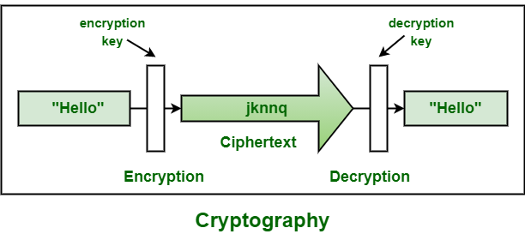

NETWORK SECURITY
Network security is a set of practices, tools, and technologies designed to protect the integrity, confidentiality, and availability of data and resources in a network. Here are the key concepts of network security :

1. Confidentiality- Ensures that sensitive data transmitted over the network is accessible only to authorized users or systems.
- Achieved through encryption, such as using protocols like SSL/TLS for securing data in transit, and access controls for restricting data access.
- Example : Encrypting data between a client and server to prevent eavesdropping.

2. Integrity - Ensures that the data transmitted over a network is not altered or tampered with during transit.
- Integrity checks are performed using cryptographic hash functions and digital signatures.
- Example: Hashing algorithms like SHA-256 can verify that a downloaded file hasn't been tampered with.
3. Availability - Ensures that network services, resources, and data are available to authorized users whenever needed.
- Availability can be compromised by attacks like Denial of Service (DoS) or Distributed Denial of Service (DDoS).
- Example: Network redundancy, load balancing, and using firewalls to block DoS attacks.

4. Authentication - Confirms the identity of users, devices, or systems accessing the network to ensure they are who they claim to be.
- Common methods include passwords, two-factor authentication (2FA), and digital certificates.
- Example: Using Multi-Factor Authentication (MFA) to verify user identity when accessing a secure network.
5. Authorization - Controls what authenticated users or systems are allowed to do on the network.
- This is often implemented through access control mechanisms such as Role-Based Access Control (RBAC) or Access Control Lists (ACL).
- Example : Employees in a company only accessing files relevant to their role.

6. Firewall - A firewall is a security device (hardware or software) that monitors and controls incoming and outgoing network traffic based on predefined security rules.
- It acts as a barrier between a trusted internal network and untrusted external networks.
- Example : Blocking unauthorized access to sensitive servers by allowing only specific traffic to pass through.

7. Intrusion Detection and Prevention Systems (IDPS) -Intrusion Detection Systems (IDS) monitor network traffic for suspicious activity and alert administrators when potential threats are detected.
- Intrusion Prevention Systems (IPS) go a step further by actively blocking or mitigating detected threats.
- Example: An IDS identifying and alerting administrators about unusual traffic patterns indicating a possible attack.
8. Virtual Private Network (VPN) - A VPN creates a secure, encrypted tunnel over a public network, such as the internet, allowing remote users or devices to access the internal network securely.
- Example: Employees working remotely using a VPN to securely connect to the company’s internal systems.

9. Encryption - Encryption ensures that data transmitted across a network is unreadable to anyone who intercepts it, except for the intended recipient who has the decryption key.
- Example: TLS (Transport Layer Security) encrypting communications between a web browser and a server to protect sensitive information like login credentials.

10. Access Control - Access control mechanisms enforce rules about who can access certain resources on the network.
- This includes physical access control (who can physically access the network infrastructure) and logical access control(who can access network resources like files and servers).
- Example : Role-Based Access Control (RBAC) assigns users permissions based on their roles within an organization.

11. Security Policy - A security policy is a set of rules and procedures that govern how network resources and data should be protected.
- It provides a framework for enforcing security protocols, managing user access, and responding to security incidents.
- Example : A company's security policy may require that all employees use 2FA and follow specific protocols for handling sensitive data.

12. Network Segmentation - Network segmentation divides a network into smaller, isolated segments to limit access and contain security breaches.
- Segmentation minimizes the spread of attacks by restricting traffic between network segments.
- Example: Dividing a company's network into internal (trusted) and external (untrusted) segments with separate firewalls.
13. Intrusion Prevention/Detection - Intrusion Detection Systems (IDS) and Intrusion Prevention Systems (IPS) monitor network traffic for signs of malicious activity and can block attacks.
- Example: An IPS preventing a brute force attack by identifying abnormal traffic patterns and blocking the source.
14. Security Information and Event Management (SIEM) - SIEM systems collect, analyze, and correlate security data from different parts of the network to provide real-time analysis and alerts on potential security threats.
- Example: A SIEM system correlates logs from firewalls, IDS, and endpoint security tools to detect and alert on coordinated attacks.
15. Backup and Recovery - A backup system ensures that critical data is regularly copied and stored so it can be recovered in the event of data loss due to attacks, hardware failure, or natural disasters.
- Example : Daily backups of servers to ensure that data can be restored after a ransomware attack

1.3 SCOPE AND FUTURE OF CRYPTOGRAPHY AND NETWORK SECURITY
SCOPE OF CRYPTOGRAPHY
1. Data Security
- Encryption: Protects data in transit (e.g., emails, messages) and at rest (e.g., files, databases) from unauthorized access.
- Cloud Security: As organizations increasingly move data to the cloud, cryptography ensures data privacy and integrity, even when stored on third-party servers.
- Blockchain and Cryptocurrencies: Cryptographic principles, especially public-key cryptography, are foundational to blockchain technology and cryptocurrencies.
2. Authentication and Access Control
- Digital Signatures: Used to verify the authenticity of a sender or document, critical in secure transactions, emails, and software distribution.
- Two-Factor and Multi-Factor Authentication (2FA/MFA): Uses cryptographic algorithms to secure access by requiring multiple credentials.
- Biometric Encryption: Encrypts and secures biometric data used for authentication (e.g., fingerprint or facial recognition).
3. Networking and Communication Security
- SSL/TLS Protocols: Secures web communications, such as those for online banking, shopping, and email.
- Virtual Private Networks (VPNs): Uses cryptographic techniques to ensure secure communication across public networks.
- Secure Email Protocols: Protocols like S/MIME and PGP encrypt emails, providing secure communication for personal and business purposes.
4. Internet of Things (IoT) Security
- With IoT devices being pervasive in homes, cities, and industries, cryptographic protocols are essential to secure data and prevent unauthorized control of devices.
- Lightweight Cryptography: Specialized algorithms for IoT devices to balance resource constraints with security requirements.
5. Post-Quantum Cryptography
- Quantum computing poses a potential threat to current cryptographic standards (e.g., RSA, ECC), so there is active research in developing quantum-resistant algorithms.
6. Digital Identity and Privacy
- Self-Sovereign Identity (SSI): Allows users to manage their own identity data using cryptographic solutions.
- Zero-Knowledge Proofs (ZKPs): Allows one party to prove knowledge of specific information without revealing the information itself, enhancing privacy.
7. Artificial Intelligence and Machine Learning Security
- Cryptographic techniques protect data used for training models, and methods like homomorphic encryption enable encrypted data to be processed by AI algorithms without decryption, preserving privacy.
8. National Security and Defense
- Governments use cryptography for secure communication, data protection, and cyber warfare strategies, as well as to protect critical infrastructure.
9. Healthcare and Personal Data Protection
- HIPAA Compliance: Cryptography helps healthcare organizations comply with regulations by securing patient data.
- Electronic Health Records (EHRs): Ensures that sensitive patient data is securely stored and shared among healthcare providers.
10. Smart Contracts and Decentralized Finance (DeFi)
- Cryptography is essential in DeFi to secure transactions, manage assets, and enable trustless financial operations without intermediaries.

SCOPE OF NETWORK SECURITY
1. Data Protection and Privacy
- Encryption: Secures data in transit and at rest, ensuring that only authorized users can access sensitive information.
- Data Loss Prevention (DLP): Monitors and manages data to prevent unauthorized access and leakage, especially valuable in industries handling sensitive data (e.g., finance, healthcare).

2. Cloud Security
- Secure Cloud Access: As companies move to the cloud, securing data and applications hosted on third-party servers is critical. Solutions like CASB (Cloud Access Security Brokers) help secure data in cloud applications.
- Hybrid and Multi-Cloud Environments: Security solutions are needed to ensure consistency in access and protection across diverse cloud platforms.
3. Endpoint Security
- Endpoint Detection and Response (EDR): Monitors devices connected to the network, detecting and responding to threats in real time.
- Mobile Device Management (MDM): Secures mobile and other devices accessing network resources, increasingly important in remote work environments.
4. Perimeter Security and Network Access Control
- Firewalls and Intrusion Detection/Prevention Systems (IDS/IPS): Monitors incoming and outgoing traffic, blocking malicious attempts to enter the network.
- Network Access Control (NAC): Restricts unauthorized devices and users from accessing network resources.
5. Identity and Access Management (IAM)
- Single Sign-On (SSO) and Multi-Factor Authentication (MFA): Helps secure user identities and prevent unauthorized access.
- Privileged Access Management (PAM): Controls access for users with elevated privileges, critical in preventing insider threats.
6. Network Monitoring and Incident Response
- Security Information and Event Management (SIEM): Collects and analyzes log data for suspicious activity, enabling faster threat detection.
- Threat Intelligence: Uses data on known threats to anticipate and defend against attacks proactively.

7. Zero Trust Architecture
- Zero Trust Network Access (ZTNA): Assumes that every access request is potentially a threat and verifies every device and user individually before allowing access.
- Micro-Segmentation: Divides the network into isolated segments to limit the spread of potential breaches.
8. Internet of Things (IoT) and OT Security
- IoT Security: Protects the growing number of IoT devices, which are often targeted due to limited security features.
- Operational Technology (OT) Security: Critical for securing industrial systems like SCADA, PLCs, and other infrastructure, especially in manufacturing, utilities, and transportation.
9. Artificial Intelligence and Machine Learning in Network Security
- AI-Driven Threat Detection: Uses machine learning to detect anomalies and identify unknown threats by analyzing network behavior.
- Automated Response and Threat Mitigation: Reduces response time by allowing automated actions when an incident is detected.
10. Secure DevOps (DevSecOps)
- Integrated Security in Development: Security is embedded directly into the software development lifecycle, ensuring applications are secure before deployment.
- Application Security Testing (AST): Identifies vulnerabilities in applications before they are deployed on a network.
11. Compliance and Regulatory Requirements
- Industry Regulations: Ensures compliance with data protection regulations like GDPR, HIPAA, and PCI-DSS, which mandate network security protocols.
- Security Audits and Assessments: Regular evaluations to ensure compliance and address security gaps.

12. Cybersecurity Skills and Career Scope
- Growing Demand for Network Security Professionals: Positions like network security analysts, security architects, penetration testers, and SOC analysts are in high demand across industries.
- Certifications and Specialized Knowledge: Certifications like CISSP, CEH, and CompTIA Security+ enhance career opportunities and expertise.
Emerging Trends in Network Security
- Quantum Cryptography: Preparing for a future where quantum computers could break current encryption methods, leading to quantum-resistant protocols.
- Secure Access Service Edge (SASE): Integrates networking and security services, making it easier to secure distributed networks and remote workforces.
- 5G Network Security: With the advent of 5G, securing high-speed connections and the vast number of devices connected to the network is critical.

Tools and Technology Used in Cryptography and Network Security
DVWA (Damn Vulnerable Web Application)
It is a web application designed for security professionals and enthusiasts to practice and learn about various web vulnerabilities in a safe and controlled environment. DVWA contains several deliberately vulnerable modules that allow users to test common attacks like SQL injection, cross-site scripting (XSS), file inclusion, and more, providing a hands-on approach to understanding web security issues.
USES OF DVWA
1. Learning Web Security
- DVWA provides a safe environment to learn about various web vulnerabilities and exploit them in a controlled setting. It helps users understand how these vulnerabilities occur, how to exploit them, and, most importantly, how to secure against them.
- Example: Understanding and practicing SQL injection, Cross-Site Scripting (XSS), and Cross-Site Request Forgery (CSRF) attacks.

2. Ethical Hacking Practice
- Aspiring ethical hackers and penetration testers can use DVWA to practice different attack techniques without fear of legal repercussions or damaging real systems. This helps in developing skills to identify and exploit weaknesses in web applications.
- Example: Testing brute force attacks on login forms, file upload vulnerabilities, and security misconfigurations.

3. Testing Web Application Security Tools
- Security tools like web vulnerability scanners (e.g., OWASP ZAP, Burp Suite) can be tested on DVWA to see how effectively they detect and report vulnerabilities.
- Example: Using automated scanning tools to detect the security issues in DVWA and analyzing the tool's effectiveness.

4. Understanding Security Misconfigurations
- DVWA allows users to simulate various security misconfigurations in a web application environment, helping them understand how improper configurations can lead to vulnerabilities.
- Example: Misconfigured file permissions or improper input validation leading to Remote File Inclusion (RFI) attacks.

5. Improving Defensive Coding Skills
- Developers can use DVWA to learn how poor coding practices can introduce vulnerabilities into web applications and how to mitigate these through secure coding techniques.
- Example: Implementing proper input validation, using prepared statements for database queries, and setting secure session management practices.

6. Exploring Different Security Levels
- DVWA provides multiple security levels: Low, Medium, High, and Impossible. These levels allow users to test their skills across varying levels of difficulty, with higher levels introducing more complex and secure protections.
- Example: A "Low" security level may have basic vulnerabilities, while a "High" security level may require more advanced techniques to exploit.

7. Experimenting with New Vulnerabilities
- Security researchers and students can use DVWA to experiment with new or emerging vulnerabilities by modifying the code or adding their own vulnerability modules.
- Example: Adding a new feature or vulnerability to DVWA and testing how modern tools and techniques can detect or exploit it.

8. Training and Education
- Universities and cybersecurity training programs often use DVWA in their curriculum to teach students real-world vulnerabilities and how to secure web applications.
- Example: In a classroom setting, instructors can use DVWA to demonstrate how different types of attacks work and guide students through mitigating these attacks.

9. Enhancing Incident Response Skills
- Security professionals can use DVWA to simulate security breaches and practice incident response, helping them prepare for real-world scenarios.
- Example: Analyzing log files and application behavior after an attempted SQL injection or XSS attack.

10. Evaluating Web Security Knowledge
- DVWA serves as a platform for self-assessment or competition-based learning where users can challenge themselves to identify and exploit vulnerabilities, and later secure them.
- Example: Penetration testers can use DVWA as part of certification preparation (e.g., OSCP, CEH) or security challenges.

SQL INJECTIONS
SQL Injection (SQLi) is a type of web security vulnerability that allows an attacker to interfere with the queries an application makes to its database. It occurs when an attacker manipulates an application's input fields or URL parameters to execute arbitrary SQL code on the backend database. This can lead to unauthorized access, data leakage, data manipulation, or even full control of the database

How SQL Injection Works:
- When user inputs (such as form data or URL parameters) are not properly sanitized, attackers can insert malicious SQL code into the input fields.
- The application, instead of treating the input as plain data, processes it as part of the SQL query, allowing the attacker to alter the query’s logic.
supports a vast array of protocols, including TCP, UDP, IP, HTTP, HTTPS, DNS, DHCP, and many others.
Types of SQL Injections:
- In-Band SQL Injection:
  - The most common type, where the attacker receives the result of the injected SQL query directly in the application's response.
  - Subtypes:
    - Error-based SQLi: The attacker exploits database error messages to gain information about the database structure.
    - Union-based SQLi: The attacker uses the UNION operator to combine the result of malicious queries with legitimate ones.
- Blind SQL Injection:
  - The attacker cannot see the output of the SQL query, but can infer results based on the application's behavior (e.g., page load time or error messages).
  - Subtypes:
    - Boolean-based Blind SQLi: The attacker sends queries that cause different responses depending on whether the query is true or false.
    - Time-based Blind SQLi: The attacker uses time delays in the database response to infer whether the query is true or false.

- Out-of-Band SQL Injection:
  - This type occurs when an attacker uses external communication methods, such as DNS or HTTP requests, to extract data from the database.

Impact of SQL Injection:
- Data Breach: Attackers can retrieve sensitive data such as usernames, passwords, or credit card information.
- Data Manipulation: Attackers can modify or delete data, altering the database's content.
- Unauthorized Access: SQL injection can lead to bypassing authentication mechanisms, allowing attackers to log in as any user, including administrators.
Database Compromise: In severe cases, attackers can execute administrative operations, such as shutting down the database or dropping entire tables

Project Introduction: Cryptography and Network Security
In an era where digital data exchange is integral to almost every aspect of life, ensuring data security has become essential. This project, conducted at DRDO's Scientific Analysis Group (SAG), addresses critical concepts of cryptography and network security to build a secure web application that protects user information through advanced encryption and secure communication protocols. The main objectives are to safeguard user data, prevent unauthorized access, and ensure secure, encrypted interactions among users.
Key Points of the Project
- User Authentication and Security:
  - Secure Registration and Login: The project implements a secure registration and login system. Passwords entered by users are hashed with the SHA-256 algorithm before storage, ensuring that no plaintext passwords are stored, which significantly reduces the risk of exposure in case of a data breach.
  - Captcha Verification: To prevent automated bot attacks, captcha is integrated into both the registration and login processes. This ensures that only legitimate users access the system, adding a layer of security against automated attacks.
- Data Protection and SQL Injection Defense:
  - Database Security: User data, including hashed passwords, is securely stored in the database. Password hashing and parameterized queries ensure the integrity and security of data.
  - SQL Injection Prevention: The project actively protects against SQL injection attacks by sanitizing user inputs and utilizing parameterized queries. This mitigates the risk of attackers exploiting database vulnerabilities through malicious inputs.
- Encrypted Messaging with Real-Time Communication:
  - AES-256 Encryption: Messages in the chat application are encrypted using AES-256, a strong encryption standard, ensuring that only authorized users can view the messages. This encryption guarantees that sensitive information remains confidential.
  - WebSocket for Instant Messaging: The project employs WebSocket for real-time messaging, which establishes a continuous connection between the client and server. This provides a smooth and responsive chat experience while ensuring data privacy through encryption.
- Wireshark Analysis for Secure Data Transmission:
  - TLS (Transport Layer Security): TLS 1.2 is used for encrypting data during transmission. Wireshark was used to analyze data packets, demonstrating how data remains encrypted and secure during transfer between client and server.
  - Handshake and Key Exchange: The project monitors the initial handshake, showing how encryption keys are exchanged securely, reinforcing the confidentiality and integrity of data being transmitted over the network.
- Frontend and Backend Security Practices:
  - Secure Coding: Backend code incorporates secure practices, including password hashing, input sanitization, and encryption methods, to prevent common vulnerabilities such as SQL injection and unauthorized data access.
  - User Interface Design: The frontend is designed for user-friendliness and security, with clear interfaces for registration, login, and chat. AES encryption libraries in the frontend provide added security, ensuring that even the chat messages are encrypted on the client side before being sent.
- Overall Application Security Framework:
  - The project employs a combination of hashed passwords, encrypted communication, captcha for user verification, and continuous WebSocket connections, creating a robust security framework. By combining these features, the project highlights best practices in both cryptography and network security for protecting user data and ensuring secure, reliable interactions

Programming Languages and Libraries
- JavaScript (React and Node.js):
  - React (Frontend): Used for creating the Signup and Login components, providing a responsive, interactive user interface. React handles dynamic input fields for user credentials, and form submission logic, ensuring a smooth user experience.
  - Node.js (Backend): Powers the server-side logic for user registration, login, password hashing, and WebSocket integration. Node.js allows the server to handle multiple user requests efficiently.
- Express.js (Node.js Framework):
  - Express.js is used on the backend to build RESTful API routes for handling user authentication (register and login endpoints). This lightweight framework simplifies request handling and facilitates interaction with MongoDB.
- MongoDB (Database):
  - MongoDB serves as the database for storing user information, such as names, emails, and hashed passwords. The project uses Mongoose (MongoDB’s ODM library for Node.js) to model user data and handle database operations.
- Socket.io:
  - Real-time Messaging: Socket.io is used to set up WebSocket connections for real-time chat functionality, enabling users to communicate instantly within the application.
  - Event Handling: Socket.io allows bidirectional communication between the client and server, which is essential for real-time updates in the chat module.
- Crypto.js (Encryption Library):
  - AES Encryption: The Crypto.js library is used to encrypt and decrypt chat messages. AES-256 is used for message encryption, ensuring secure end-to-end communication.
  - SHA-256 Hashing: Passwords are hashed using SHA-256 from the Crypto.js library before being stored in the database, providing secure authentication for user credentials.
- HTML and CSS:
  - HTML: The structure of the frontend is built using HTML, which includes forms for user input (e.g., login, registration, and message input).
  - CSS: Basic styling is applied using CSS, along with Bootstrap classes (e.g., bg-secondary, vh-100) to create a responsive and visually appealing design.
- Axios (HTTP Client):
  - Data Transmission: Axios is used in the frontend to make HTTP requests to the backend API for registering and logging in users. It simplifies sending and receiving data between the client and server.
- Bootstrap (CSS Framework):
  - Bootstrap is used for styling and layout, such as buttons, form elements, and containers, ensuring the frontend is responsive and visually consistent.
Security and Network Protocols
- TLS (Transport Layer Security):
  - TLS 1.2 is used to secure data transmission over the network. This protocol ensures that all data sent between the client and server is encrypted, which is critical for protecting sensitive user information from interception.
- REST API Architecture:
  - Endpoints for Register and Login: The project’s server uses RESTful API endpoints for handling user registration (/register) and login (/login). This structure separates client-server interactions and enables easy API management.
- WebSocket Protocol:
  - WebSocket enables persistent, real-time communication between the client and server. Socket.io uses this protocol to facilitate real-time message updates in the chat module, allowing instant message delivery and feedback.
Components Overview
- Signup and Login Components (React)
  - These components are created using React hooks, such as useState, for handling form data. Axios is used to submit the form data to the backend. User passwords are hashed on the backend using SHA-256 before being saved to MongoDB.
- Server Code (Express, Socket.io, MongoDB):
  - The server, created using Express.js, handles user authentication requests. It uses MongoDB for storing user data and Socket.io for managing WebSocket connections in real-time chat.
- WebSocket Chat System (Socket.io, CryptoJS):
  - Messages are encrypted on the client side using AES-256 encryption before being sent through WebSocket to the server. The server decrypts the messages using the same AES-256 key, ensuring secure real-time communication.
- Password Hashing and Authentication (Crypto.js SHA-256):
  - The comparePasswords function on the server hashes the entered password and compares it to the stored hashed password. This way, user passwords remain secure even if the database is compromised.
Summary of Technologies
- Languages: JavaScript (React, Node.js)
- Libraries/Frameworks: React, Express.js, Socket.io, Crypto.js, Axios
- Database: MongoDB
- Protocols: WebSocket, REST API, TLS 1.2
- Frontend Tools: HTML, CSS, Bootstrap for layout and styling
By combining these technologies, the project offers a robust and secure web application with features like encrypted messaging, secure user authentication, and real-time updates, following modern security standards and best practices

PROJECT SCREEN SHOT :
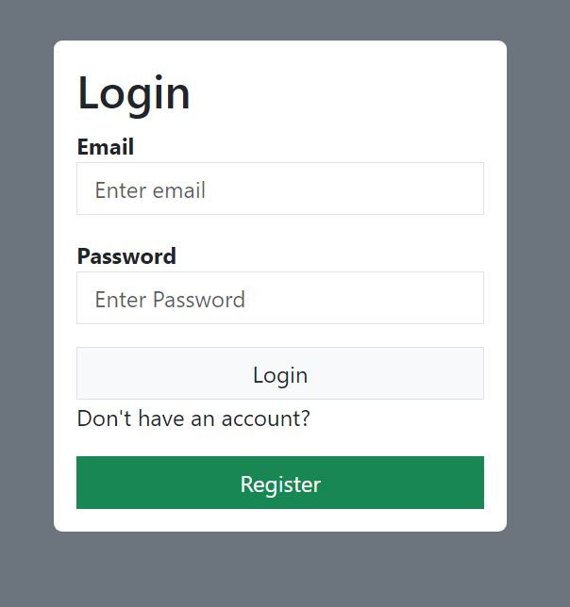
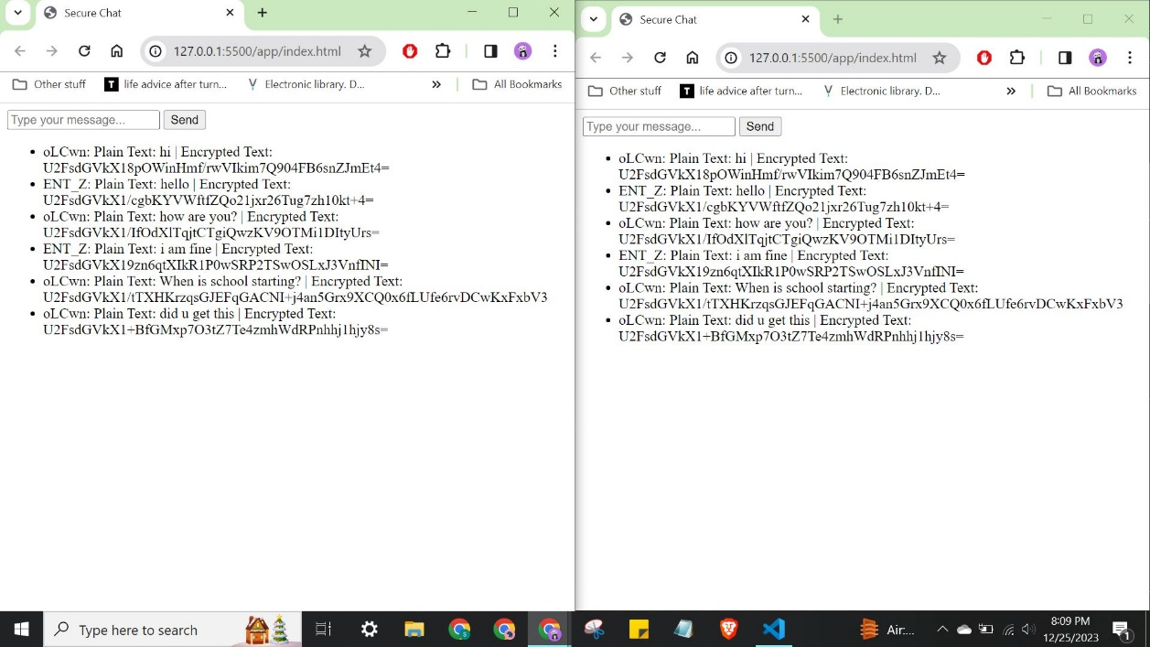
The above images show the different screen in the projects from the login, registration, captcha, and chat screens.

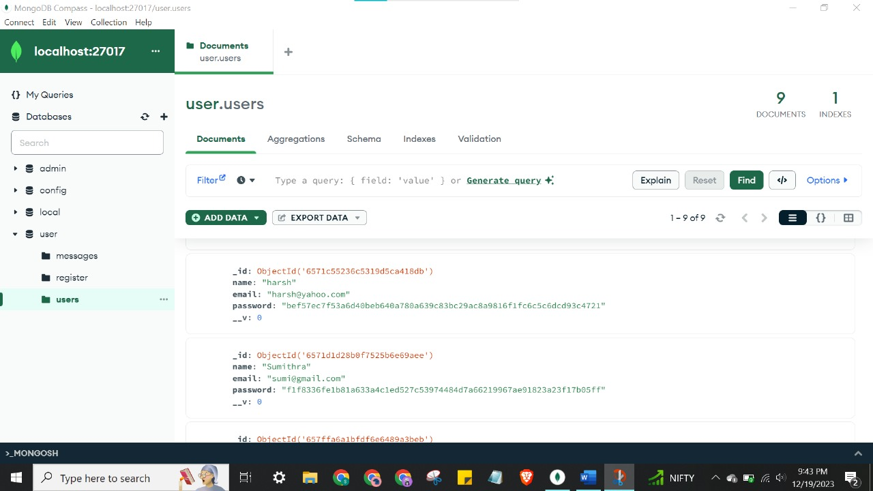
The above image shows the database storage of users once they register. Here the passwords stored are not the plain passwords but instead the hashed password.
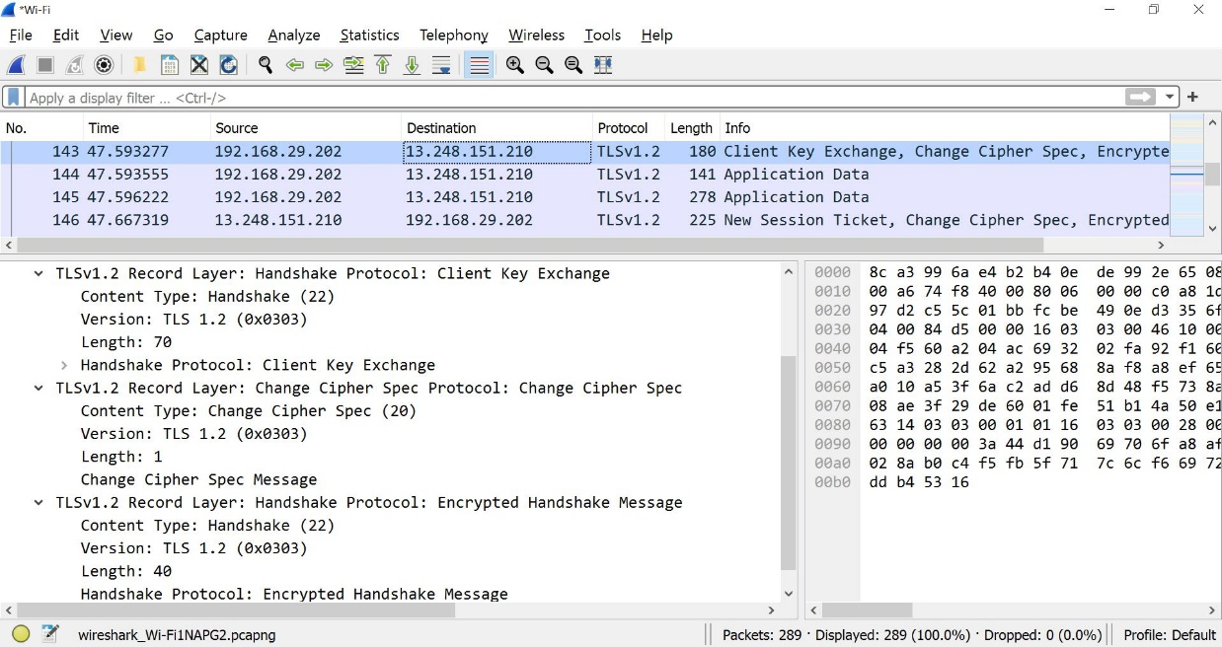
Using Wireshark, the web-app was run. Here we can see the handshaking process which takes place when the app starts requests to send data. From decrypting the message sent using the key to exchanging the algorithm for the cipher and encrypting the message, the transport layer protocol is enabled

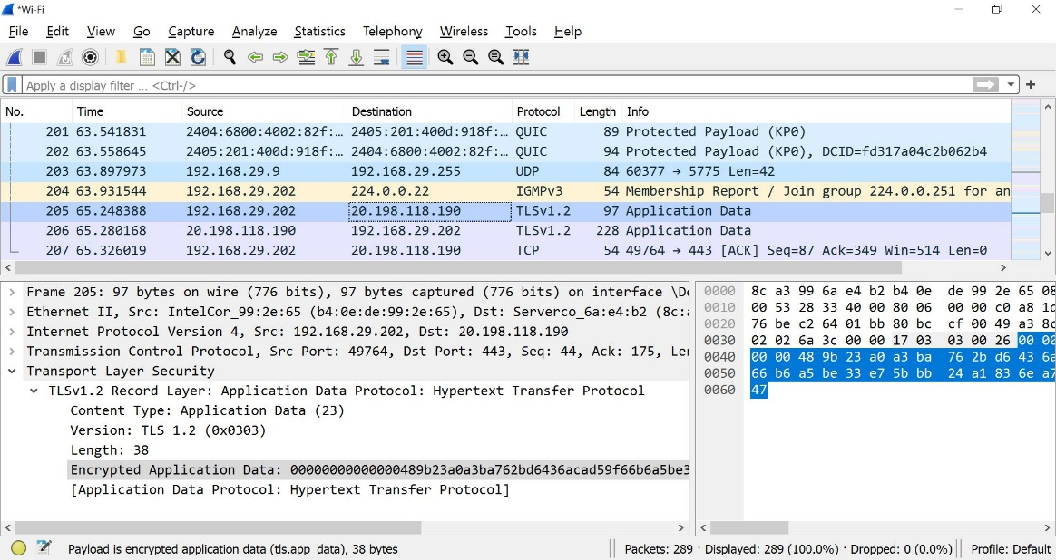
Here through the same transport protocol TLSv1.2 wee can see that the application data is sent from one host IP address to another. In the expanded information, it is shown that the data has been encrypted and cannot be plainly viewed by us unless we provide Wireshark the key which was used during the AES-256 encryption process.

CODE
Signup:
import { useState } from "react";
import { Link } from "react-router-dom";
import axios from 'axios'
import { useNavigate } from 'react-router-dom';

function Signup(){
const [name,setName] = useState()
const [email,setEmail] = useState()
const [password,setPassword] = useState()

const handleSubmit = (e) => {
e.preventDefault()
axios.post('http://localhost:3001/register', {name, email, password})
.then(result => {console.log(result)
Navigate('/login')
})
.catch(err=> console.log(err))
}

return(
<div className= "d-flex justify-content-center align-items-center bg-secondary vh-100">
<div className="bg-white p-3 rounded w-25">
<h2>Register</h2>
<form onSubmit={handleSubmit}>
<div className="mb-3">
<label htmlFor="email">
<strong>Name</strong>
</label>
<input
type="text"
placeholder="Enter Name"
autoComplete="off"
name="email"
className="form-control rounded-0"
onChange={(e) => setName(e.target.value)}
/>
</div>
<div className="mb-3">
<label htmlFor="email">
<strong>Email</strong>
</label>
<input
type="email"
placeholder="Enter email"
autoComplete="off"
name="email"
className="form-control rounded-0"
onChange={(e) => setEmail(e.target.value)}
/>
</div>
<div className="mb-3">
<label htmlFor="email">
<strong>Password</strong>
</label>
<input
type="password"
placeholder="Enter Password"
name="password"
className="form-control rounded-0"
onChange={(e) => setPassword(e.target.value)}
/>
</div>
<button type="submit" className= "btn btn-success w-100 rounded-0">
Register
</button>
</form>
<p>Already have an account?</p>
<Link to="/login" className="btn btn-default border w-100 bg-light rounded-0 text-decoration-none">
Login
</Link>
</div>
</div>

); }

export default Signup;
Login:
import React from 'react';
import { useState } from 'react';
import { Link, useNavigate } from 'react-router-dom';
import axios from 'axios';

function Login() {
const [email, setEmail] = useState('');
const [password, setPassword] = useState('');
const navigate = useNavigate();

const handleSubmit = (e) => {
e.preventDefault();
axios.post('http://localhost:3001/login', { email, password })
.then(result => {
console.log(result);
if (result.data === 'Success') {
navigate('/captcha');
}
})
.catch(err => console.log(err));
};

return (
<div className="d-flex justify-content-center align-items-center bg-secondary vh-100">
<div className="bg-white p-3 rounded w-25">
<h2>Login</h2>
<form onSubmit={handleSubmit}>
<div className="mb-3">
<label htmlFor="email">
<strong>Email</strong>
</label>
<input
type="email"
placeholder="Enter email"
autoComplete="off"
name="email"
className="form-control rounded-0"
onChange={(e) => setEmail(e.target.value)}
/>
</div>
<div className="mb-3">
<label htmlFor="email">
<strong>Password</strong>
</label>
<input
type="password"
placeholder="Enter Password"
name="password"
className="form-control rounded-0"
onChange={(e) => setPassword(e.target.value)}
/>
</div>
<button type="submit" className="btn btn-default border w-100 bg-light rounded-0 text-decoration-none">
Login
</button>
<p>Don't have an account?</p>
<Link to="/register" className="btn btn-success w-100 rounded-0">
Register
</Link>
</form>
</div>
</div>
);
}

export default Login;

Server:
const express = require("express");
const mongoose = require('mongoose');
const cors = require("cors");
const UserModel = require('./models/User');
const MessageModel = require('./models/Message');
const crypto = require("crypto");
const { Server } = require("socket.io");
const CryptoJS = require('crypto-js');
const http = require('http');

const app = express();
const server = http.createServer(app);

app.use(cors());

mongoose.connect("mongodb://127.0.0.1:27017/user", { useNewUrlParser: true, useUnifiedTopology: true });

app.use(express.json());

function comparePasswords(plainPassword, hashedPassword) {
const hash = crypto.createHash('sha256').update(plainPassword).digest('hex');
return hash === hashedPassword;
}
app.post("/login", (req, res) => {
const { email, password } = req.body;

UserModel.findOne({ email: email })
.then(user => {
if (user) {
if (comparePasswords(password, user.password)) {
res.json("Success");
} else {
res.status(401).json("Invalid credentials");
}
} else {
res.status(401).json("Invalid credentials");
}
})
.catch(err => {
console.error(err.message);
res.status(500).json({ error: 'Internal Server Error' });
});
})

app.post('/register', (req, res) => {
const { name, email, password } = req.body;

const hash = crypto.createHash('sha256').update(password).digest('hex');

UserModel.create({ name, email, password: hash })
.then(user => res.json(user))
.catch(err => res.json(err));

})

const PORT = process.env.PORT || 3001;

server.listen(PORT, () => {
console.log(`Server is running on port ${PORT}`);
});

Websocket connection:
import { createServer } from "http";
import { Server } from "socket.io";
import express from "express";
import path from "path";
import CryptoJS from "crypto-js";

const app = express();
const httpServer = createServer(app);

const io = new Server(httpServer, {
cors: {
origin: process.env.NODE_ENV === "production" ? false : ["http://localhost:5500", "http://127.0.0.1:5500"],
},
});

app.get("/", (req, res) => {
res.sendFile(path.join(__dirname, "index.html"));
});

io.on("connection", (socket) => {
console.log(`User ${socket.id} connected`);

socket.on("message", ({ userId, plainText, encryptedMessage }) => {
const decryptedMessage = decryptMessage(encryptedMessage, "yourSecretKey");
console.log(`${userId.substring(0, 5)}: ${decryptedMessage}`);
io.emit("message", { userId, plainText, encryptedMessage });
});
});

httpServer.listen(3500, () => console.log("listening on port 3500"));

function decryptMessage(ciphertext, key) {
const bytes = CryptoJS.AES.decrypt(ciphertext, key);
return bytes.toString(CryptoJS.enc.Utf8);
}

Chat backend:
const socket = io('ws://localhost:3500');
const encryptionKey = "yourSecretKey"; // Replace with your actual secret key

function sendMessage(e) {
e.preventDefault();
const input = document.getElementById('messageInput');
if (input.value) {
const plainText = input.value;
const encryptedMessage = encryptMessage(plainText, encryptionKey);
socket.emit('message', { userId: socket.id, plainText, encryptedMessage }); // Include user ID
input.value = "";
}
input.focus();
}

function encryptMessage(message, key) {
const ciphertext = CryptoJS.AES.encrypt(message, key);
return ciphertext.toString();
}

document.getElementById('messageForm').addEventListener('submit', sendMessage);

// Listen for messages
socket.on('message', ({ userId, plainText, encryptedMessage }) => {
const li = document.createElement('li');
li.textContent = `${userId.substring(0, 5)}: Plain Text: ${plainText} | Encrypted Text: ${encryptedMessage}`;
document.getElementById('messageList').appendChild(li);
});

function decryptMessage(ciphertext, key) {
const bytes = CryptoJS.AES.decrypt(ciphertext, key);
return bytes.toString(CryptoJS.enc.Utf8);
}

Chat frontend:

<!DOCTYPE html>
<html lang="en">
<head>
<meta charset="UTF-8">
<meta name="viewport" content="width=device-width, initial-scale=1.0">
<title>Secure Chat</title>
<!-- Adjust the path based on your project structure -->
<script src="node_modules/crypto-js/crypto-js.js"></script>
<script src="https://cdnjs.cloudflare.com/ajax/libs/socket.io/4.1.2/socket.io.js"></script>
</head>
<body>

<form id="messageForm">
<input type="text" id="messageInput" placeholder="Type your message..." />
<button type="submit">Send</button>
</form>

<ul id="messageList"></ul>

<script src="app.js"></script>

</body>
</html>

Application layout:
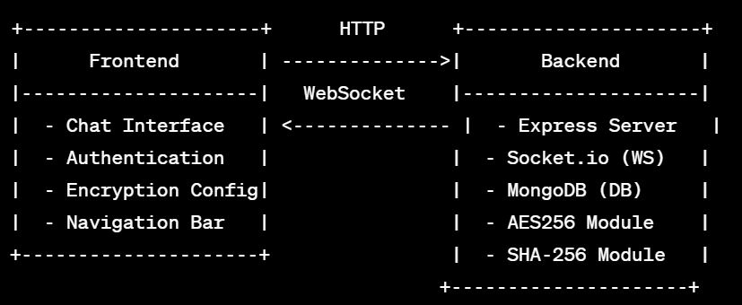

PROJECT SUMMARY/CONCLUSION
Project Summary on Cryptography and Network Security
This project on Cryptography and Network Security was designed to simulate and implement security features in a web application, focusing on aspects such as secure login, data encryption, and secure communication. The application integrates multiple security components, including SQL Injection prevention, encrypted messaging, and secure data handling. Below is a breakdown of each module and the technologies used, based on the screenshots provided.
1. User Registration and Login System with Security Measures
- The User Registration screen allows new users to create an account by providing essential details. Passwords are hashed before being stored in the database, ensuring that plaintext passwords are never exposed, even if database security is compromised. The screenshot shows the hashing of passwords using SHA-256, which is a secure hashing algorithm to prevent easy decoding of stored passwords.
- The Login System utilizes a secure authentication process where user credentials are verified against the hashed values stored in the database. This system includes validations to protect against SQL Injection, ensuring that user inputs are properly sanitized before interacting with the database.
- Captcha Integration was implemented as an additional security layer. This helps prevent bot attacks and automated logins by requiring users to complete a simple visual verification before accessing the application. The screenshot reflects the captcha as a step in the login process, adding a hurdle for unauthorized scripts.
2. Database Storage and Security
- The database screenshot showcases the structure where user information, including hashed passwords, is stored. Passwords are hashed using SHA-256 before storage, preventing them from being stored in plaintext. By implementing hashing, even if a data breach occurs, attackers will not have access to the original passwords, as SHA-256 is designed to be irreversible.
- Alongside hashed passwords, additional security mechanisms were used to prevent SQL injection attacks, ensuring that user inputs are filtered and validated before any database interaction occurs. This prevents malicious SQL commands from being executed, maintaining the integrity and confidentiality of user data.

3. Encrypted Messaging and Chat Functionality
- The project’s Chat Module allows for real-time communication between users, utilizing end-to-end encryption to secure messages. Each message sent in the chat is encrypted using AES-256, a robust encryption standard, before transmission, ensuring that only authorized recipients can decrypt and read the messages. The screenshot from the chat module shows messages displayed in both plaintext and encrypted form to demonstrate how the encryption operates.
- The Socket.io WebSocket Library is used for real-time data transfer in the chat module. By establishing a persistent connection, this library allows messages to be sent and received instantly. The encrypted data ensures that even if a third party intercepts the communication, they won’t be able to decipher it without the correct decryption key.
4. Wireshark Analysis for Data Transmission Monitoring
- Wireshark, a network protocol analyzer, was employed to monitor data transmission and demonstrate the encryption in action. The screenshot from Wireshark shows the application’s data packets with details on how data was encrypted and transmitted securely using TLS (Transport Layer Security) version 1.2.
- The Wireshark analysis showcases the initial handshaking process, where encryption algorithms and keys are exchanged between the client and server. By utilizing TLS, the project secures the transport layer, preventing attackers from reading data in transit, thus protecting user messages and sensitive information from interception.
5. Source Code Implementation for Security Features
- The code screenshots illustrate various backend functions responsible for user registration, login, and secure messaging:
  - Signup and Login Logic: The backend code for signup and login includes secure hashing for passwords and the use of express.js and MongoDB for managing users. Hashing functions ensure that plaintext passwords are never saved in the database.
  - Encryption Functions: The AES encryption and decryption functions are shown, demonstrating how user messages are encrypted before sending and decrypted upon receipt. These functions rely on a shared secret key, ensuring only authorized users can access the messages.
  - Socket.io for Real-Time Messaging: The chat backend code employs WebSocket connections, enabling encrypted real-time communication. Each message is encrypted on the client-side and decrypted on the server-side to maintain confidentiality.

6. Security Layers and SQL Injection Prevention
- SQL Injection (SQLi) attacks, where attackers manipulate database queries via user inputs, are common web vulnerabilities. This project took active measures to mitigate SQLi by using parameterized queries, as shown in the backend code. By sanitizing inputs and restricting special characters, the system ensures that only legitimate queries are executed.
- SQLi defense measures include encoding user inputs and setting strict access controls for database interactions. These practices prevent unauthorized users from gaining access to or manipulating sensitive data stored in the database.
7. WebSockets and Encrypted Communication in Chat Application
- WebSocket Integration: The chat functionality leverages WebSocket for a continuous connection between the client and server, facilitating instant message transmission. Encrypted communication ensures that messages are secure, even over a persistent WebSocket connection.
- AES Encryption: Messages are encrypted using AES-256 encryption before transmission and decrypted upon receipt. The encryption key remains private, and only users with the correct key can view the plaintext messages. This layer of encryption makes it impossible for unauthorized individuals to intercept and understand chat content.
8. Application Layout and User Interface
- The application’s layout was developed to be user-friendly, ensuring that users can easily navigate through registration, login, and chat sections. Each screen has been designed with security best practices in mind, such as hiding passwords on input and securing data exchange between the client and server.
- The Chat Frontend is developed using HTML and JavaScript, with libraries like CryptoJS for AES encryption. The user interface provides a seamless chat experience while ensuring that all messages are encrypted and secure.
Conclusion
This project highlights critical aspects of cryptography and network security within a web application. By implementing strong authentication, data encryption, and secure data transmission, the project demonstrates how to build secure systems that protect user information and prevent common vulnerabilities like SQL Injection. The use of hashed passwords, captcha, AES encryption, and WebSocket communication collectively contribute to a robust security framework. Through practical application, this project emphasizes the importance of cryptographic techniques and network security principles, providing a strong foundation for developing secure applications in the real world.
Future Scope of Cryptography

1. Quantum-Resistant Cryptography:
- With advancements in quantum computing, traditional cryptographic algorithms may become vulnerable. Quantum computers could potentially break widely-used algorithms like RSA and ECC. The future of cryptography includes developing (post-quantum algorithms) that can withstand quantum attacks, ensuring data security in a quantum-enabled world.

2. Enhanced Encryption for IoT Devices:
- As the Internet of Things (IoT) expands, millions of connected devices will require secure communication channels. Lightweight, efficient cryptographic algorithms tailored to IoT devices with limited processing power and battery life are an emerging focus, aiming to protect vast networks of interconnected devices from cyber threats.

3. Zero-Knowledge Proofs (ZKP):
- Zero-knowledge proofs allow one party to prove they know a piece of information without revealing the information itself. ZKPs have applications in secure identity verification, privacy-preserving transactions, and blockchain, promising a future of enhanced privacy for users.

4. Blockchain and Cryptographic Security in Decentralized Systems:
- Cryptography is essential for blockchain security, and its future applications include improving smart contract security, protecting user privacy, and creating fully decentralized systems. Innovations in cryptographic protocols will further enhance blockchain scalability and trust.

5. Homomorphic Encryption for Secure Data Processing :
- Homomorphic encryption allows data to be processed and analyzed while still encrypted, which is useful in cloud computing and data analytics. This technique is gaining interest for applications in finance, healthcare, and artificial intelligence, where privacy is critical but computation on data is necessary.
6. Biometric Encryption :
- Future encryption methods are likely to incorporate biometrics (e.g., fingerprints, retinal scans) for more secure authentication. Biometrics combined with cryptography could strengthen multi-factor authentication and secure identity verification.

7. Artificial Intelligence in Cryptographic Security :
- AI is increasingly used to detect vulnerabilities and predict cryptographic threats, improving security protocols. AI-driven cryptographic algorithms may offer adaptive, real-time encryption techniques, improving the security of dynamic data environments.

8. End-to-End Encryption for Everyday Communication :
- The demand for secure communication is rising as privacy concerns grow. Future cryptography will likely make end-to-end encryption standard in messaging, email, and other communication platforms, protecting user data across all channels.

Conclusion
Cryptography has become the backbone of modern digital security, providing essential tools to secure communication, protect data integrity, and preserve user privacy. As technology evolves and cyber threats become more sophisticated, cryptography must continue to innovate. Advancements such as quantum-resistant algorithms, homomorphic encryption, and biometric security reflect the adaptability of cryptographic science.

Looking forward, cryptography will remain crucial in safeguarding data across various sectors, including finance, healthcare, government, and personal communications. By developing new algorithms and methods to address future threats—like quantum computing and IoT vulnerabilities—cryptography will help ensure secure and trustworthy digital interactions in an increasingly interconnected world.

